**\*Please make a copy of this document and include this in your GitHub repository for your submission, using the tag #AndroidDevChallenge\***

**Tell us what your idea is.**

*Describe in 250 words what the feature or service will do and how you’ll use Machine Learning to push the bar:*

We would like to develop a digital careers planning tool for our students. The tool would be used collaboratively by students, tutors and local employers to support students’ professional development and encourage more students to seek employment in the region after graduation. For example, the tool would enable students to evaluate their own skillset against job roles advertised in the area; it could allow prospective employers to register interest in individuals and set them skills development challenges with incentives offered (e.g. informal meeting, short placement, endorsement on social media etc.). The app could also suggest local training and networking opportunities. We would like you to thiink of our application idea as something like a ‘local tech skills incubator’; one which aims to encourage local industry to take practical steps ito support emerging talent.

To realise our goals we intend to use data APIs and other open data sources to build a digital skills ontology for our region. To help us do this we intend to use Google’s Natural Language Toolkit. We hope that, in developing a comprehensive skills ontology, we will capture the value employers place on soft skills as well as specific tools and methodologies. We would then use machine learning to build a predictive model from the skills ontology data set.

**Tell us how you plan on bringing it to life.**

*Describe where your project is, how you could use Google’s help in the endeavor, and how you plan on using On-Device ML technology to bring the concept to life. The best submissions have a great idea combined with a concrete path of where you plan on going, which should include:*

* *(1) any potential sample code you’ve already written,*

*We started developing our idea at an Open Data Institute ‘Hack for Impact’ event. A that stage we were aiming to develop something very basic that could kick-start a conversation with employers and students t and help us find out if there was an appetite for our idea. We developed a simple web-based app using a single open data source compiled by Tech Nation combined with Twitter data. The result was ‘Skills Bubble Pop’, a visual tool which simply infers popularity of different tools from tweets data. You can find the code in the skills-bubble-pop directory of this repo. Please note that the Twitter data sets have not been publicised in the repo.*

*Having established there was some interest in the idea of a digital skills ontology, we thought about how we might develop the idea into something that had a more concrete application. We put the idea of a ‘’careers planning tool’ to students as part of an assignment. They suggested some features for our app, some of which are pictured below.*

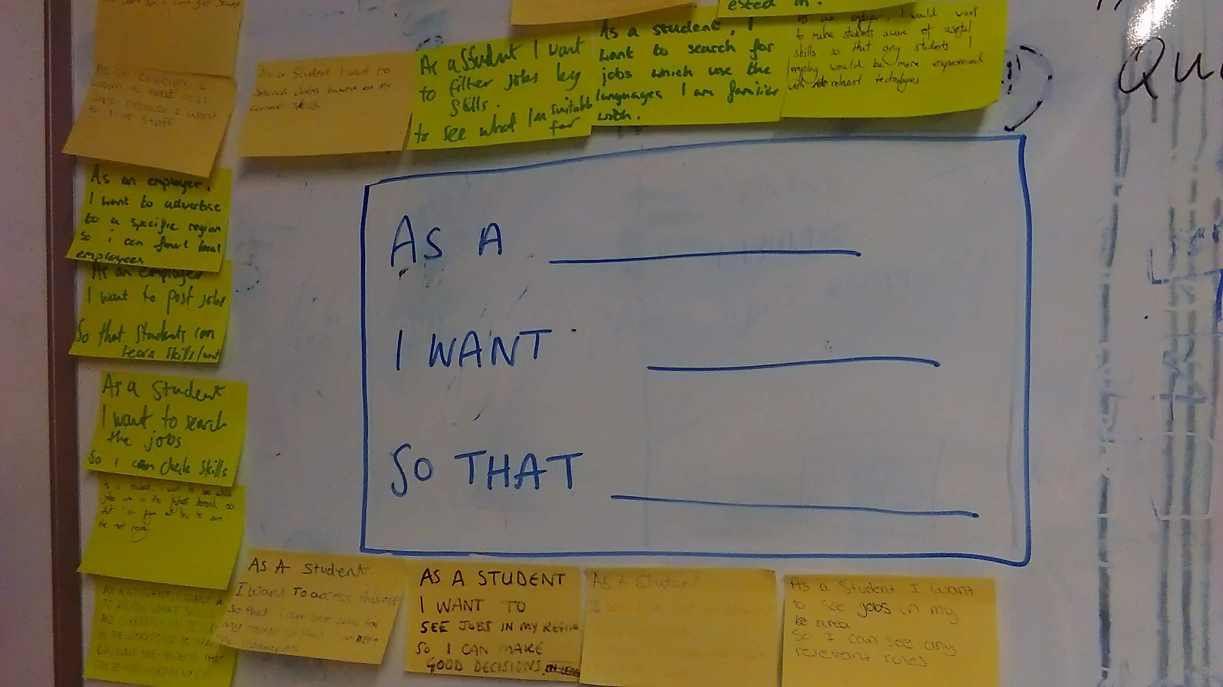

*The next steps are to collect and curate data which we can use to develop our ontology.*

*We would then hope to develop a more realistic prototype for the application by May 2020.*

* *(2) a list of the ways you could use Google’s help,*
* *Data sets*
* *Credits for the Google Cloud Platform and APIs*
* *Consultation on design and technical specification for app*
* *We would also welcome Google’s help to offer us some training on the Natural Language and Machine Learning toolkits. We would also love it if our students could be involved in the process, particularly those taking Applied Artificial Intelligence as a final year optional module.*
* *Similarly, we would welcome training on Android SDK. Our students are taught Android SDK in their second year, but not all of our staff have had this training. Since we take a very collaborative approach to the delivery of our degree programme, and a large proportion of the coursework is group project based, it would be wonderful to have this opportunity to learn together (and produce something genuinely useful in the process!)*
* *(3) as well as the timeline on how you plan on bringing it to life by May 1, 2020.*

*If selected we would aim to develop a prototype of the application in Android before May 2020. This*

*prototype would not have all the proposed functionality implemented. Initially we would prioritise the presentation of ‘skills maps’ for different job roles based on the available data. We would also implement a skills questionnaire which would allow students’ skillsets to be compared against available roles.*

**Tell us about you.**

A great idea is just one part of the equation; we also want to learn a bit more about you. Share with us some of your other projects so we can get an idea of how we can assist you with your project.

We are a small team of academic staff who are working together to deliver a new computer science undergraduate programme at Leeds Trinity University. Leeds Trinity was formerly an FE college and we retain a very vocational outlook with work placements built into all of our degree programmes. Unlike our competitors we attract mainly local students, many of whom are the first in their family to go to University. Supporting these students to find graduate employment locally is therefore a top priority for us, so the more we can do to connect with industry and make what we are teaching relevant, the better.

**Next steps.**

* Be sure to include this cover letter in your GitHub repository
* Your GitHub repository should be tagged #AndroidDevChallenge
* Don’t forget to include other items in your GitHub repository to help us evaluate your submission; you can include prior projects you've worked on, sample code you've already built for this project, or anything else you think could be helpful in evaluating your concept and your ability to build it
* [**The final step is to fill out this form to officially submit your proposal.**](https://docs.google.com/forms/d/e/1FAIpQLSe43koQL33IzgxXQl29Ex3AhFuqd4hQzxLiXREqwRkDGtx1vA/viewform?usp=sf_link)